Plant Vogtle Units 3 & 4

Semi-Annual
Construction Monitoring Report

August 2009

Docket No. 29849-U

EXECUTIVE SUMMARY

Pursuant to the stipulation (the “Stipulation”) adopted in the Georgia Public Service Commission’s (the “Commission”) Order in Docket Number 27800-U (“Certification Order”), Georgia Power Company (“Georgia Power” or the “Company”) submits this Semi-Annual Construction Monitoring Report (the “Report”) to the Commission. Section 2(c) of the Stipulation requires the Report to be filed semi-annually, with the first Report due on August 31, 2009. This is the first of those reports.

This executive summary provides an overview of the information contained in the Report, and supports the Company’s assertion that construction of new units 3 and 4 at Plant Vogtle (the “Units”) (sometimes referred to as the “Project”) is on schedule and on budget, and demonstrates that cost pressures are being actively and prudently managed.

The body of this Report responds to the 15 items the Stipulation specified would be addressed in each report. However, several key developments and issues should be highlighted to put the Project’s progress in context.

The Project is on schedule. A Level 1 Schedule showing progress to date against the milestones is Exhibit 1 to this Report. To provide more than just a snapshot view of the Project, the Company has also incorporated into this Report the information from the Monthly Reports submitted to the Commission by Georgia Power and the Engineering Procurement and Construction (“EPC”) Status Reports submitted to Georgia Power, Oglethorpe Power Corporation, Municipal Electric Authority of Georgia and the City of Dalton (the “Co-Owners”) by Westinghouse Electric Company LLC (“Westinghouse”) and Stone & Webster, Inc. (together with Westinghouse, the “Consortium”) during the same period. The June 2009 Monthly Report is Exhibit 2 and the June 2009 EPC Status Report is Exhibit 3. The Company points out however, that the EPC Status Reports are prepared by the Consortium and the Company does not necessarily endorse every position taken in those reports.

The Company continues to exercise prudent control over the Project. The Company and its Co-Owners retained PricewaterhouseCoopers (“PWC”) to conduct a “readiness review” which was a thorough, risk-based assessment of project management, financial reporting and oversight. This review began in 2008 and continued into the first quarter of 2009. It resulted in several key observations and recommendations that have been incorporated into the project management structure and adopted into the Company’s financial reporting procedures.

PWC has also been retained to serve as an Independent Project Advisor. PWC will provide an independent evaluation of Project governance and control structure, and provide senior management with assessments against best industry practices. PWC will also provide contract administration support by reviewing data supplied by vendors for compliance with contract terms and conditions.
The Company has adopted a streamlined and effective project management structure that includes the creation of an Executive Vice President of Nuclear Development position that reports directly to the CEOs of Georgia Power and Southern Nuclear. The Vogtle Project Management Board, which includes senior executive representatives from the Company and the Co-Owners, was established to act as the highly integrated senior management oversight board. In addition, a Vogtle Expansion Oversight Committee (“VEOC”) was created that draws together senior Southern Company executives. The VEOC is chaired by the CEO of Georgia Power, co-Chaired by the CEO of Southern Nuclear, and includes the CEO of Southern Company, the CFO of Southern Company, and the COO of Southern Company. The Executive Vice President of Nuclear Development and the General Counsel of Southern Company also participate in the VEOC.

One primary consideration for the Project is the safety of the work force. The Project has had one recordable safety event in 2009. It had none in 2008.

The most significant licensing development was the issuance of the Early Site Permit (“ESP”) and the Limited Work Authorization on August 26, 2009. While the Company recognizes that this is beyond the scope of this Report (this Report covers activities through June 30, 2009) it is such a significant event that it would render a discussion of the ESP progress as it existed on June 30th irrelevant. The Company and the Consortium continue to finalize the Design Control Documents (“DCD”) at the Nuclear Regulatory Commission (“NRC”) and the Combined Operating License Application (“COLA”) review remains on schedule. The Company has responded to over 1,600 requests for additional information from the NRC. The Company is watching and managing several areas of exposure to the schedule and cost, but as of now it believes the Project will stay on budget and on schedule from a licensing perspective.

Overall, engineering continues to be on schedule and on budget. While some engineering items are behind schedule, none affect the critical path, and recovery plans are in place for those items. The turbine building is being extended as compared to the original design to allow for increased space for turbine operating and maintenance activities. Design finalization is expected to be essentially complete in April 2011.

Construction activities continue to be on schedule and on budget. Top soil removal began June 22, 2009. Heave and settlement monitoring equipment was being installed for Unit 3 as of June 30th, with installation of Unit 4 equipment commencing in July. Major excavation begins after heave and settlement monitoring equipment is installed.

The Consortium continues the procurement of major components and contractors. So far it has awarded REDACTED contracts, REDACTED of which are within the Southern Company territory, and REDACTED of those REDACTED are within 100 miles of the Project site.

Table 1.1 reflects the status of the Project’s budget as of June 30th. Several items are noteworthy. First, escalation of the REDACTED REDACTEDand the REDACTED has been REDACTED in the certification. This is reflected in the REDACTED REDACTED REDACTED REDACTED REDACTED REDACTED REDACTED REDACTED REDACTED REDACTED REDACTED REDACTED REDACTED REDACTED REDACTED REDACTED REDACTED REDACTED REDACTED REDACTED REDACTED REDACTED REDACTED REDACTED REDACTED REDACTED REDACTED REDACTED REDACTED REDACTED REDACTED REDACTED REDACTED REDACTED REDACTED REDACTED REDACTED REDACTED REDACTED REDACTED REDACTED REDACTED REDACTED REDACTED REDACTED REDACTED REDACTED REDACTED REDACTED REDACTED REDACTED REDACTED REDACTED REDACTED REDACTED REDACTED REDACTED REDACTED REDACTED REDACTED REDACTED.

The second item to be noted is that the Company has included an additional contingency of $REDACTED to account for the difference between the methodology under which the financing costs of the Project was approved by the Commission and the way they will be collected pursuant to the Georgia Nuclear Energy Financing Act, O.C.G.A. § 46-2-25(c.1) (“SB 31”). During the certification proceeding, the Company promised to lower the in-service cost of the Project from $6.4 billion to $4.529 billion if the Company’s request to include Construction Work In Progress (“CWIP”) in rate base was granted. The Company has kept that commitment in this filing. However, because SB 31 will collect the 2009 and 2010 financing costs slightly differently than proposed by the Company in its certification request, there is an additional $REDACTED which is now set aside for contingency. If it is not used, of course, the in-service cost will be even lower than $4.529 billion.

While no EPC change orders have been approved to date, and while the Project continues to be on schedule and on budget, that is not to suggest that this is not a complex and large project with daily management challenges. Many issues are being managed and watched, some of which could put pressure on the schedule and budget. Among those items is finalization of the DCD, which could impact the progress of the COLA. REDACTED REDACTED REDACTED REDACTED is not expected to put upward pressure on the certified cost, but it is an open item to be managed. We expect that the Consortium will seek REDACTED REDACTED REDACTED. We will manage that request such that it does not harm retail customers. We are examining the REDACTED REDACTED REDACTED REDACTED REDACTED REDACTED REDACTED. We are also managing REDACTED REDACTED at the site. It appears that there is a possibility that the Consortium may need to REDACTED REDACTED REDACTED REDACTED. We will continue to keep the Commission and the Staff advised of these issues, and others as they develop, through the monthly and semi-annual reports.

As agreed in the Stipulation that was incorporated into the Certification Order, the Company responds to the 15 specified items, in the order in which they appear in Section 2(d)(1-15) of the Stipulation as follows:

- The reasons for any additional change in the estimated costs of the units since the process began.

The projected in-service cost of the Units has changed from $6.4 billion to $4.529 billion. The change is a result of the impact of placing CWIP into rate base as authorized by the Commission’s Certification Order for construction of the new Units, and as supported by SB 31. Initially, the Company requested that the Commission allow it to place CWIP in rate base beginning on January 1, 2011 and otherwise accrue Allowance for Funds Used During Construction (“AFUDC”) from the time of certification through December 31, 2010. The accrued AFUDC amount would have been recovered in rates after the Units were in commercial operation. However, the provisions of SB 31 require the Company to recover the AFUDC accrued through December 31, 2010 in rates over the five (5) year period from 2011 through 2015.

The accrued AFUDC at December 31, 2010 is projected to total $REDACTED. This $REDACTED will be held in contingency should such funds be needed, as shown in Table 1.1 below.

Table 1.1
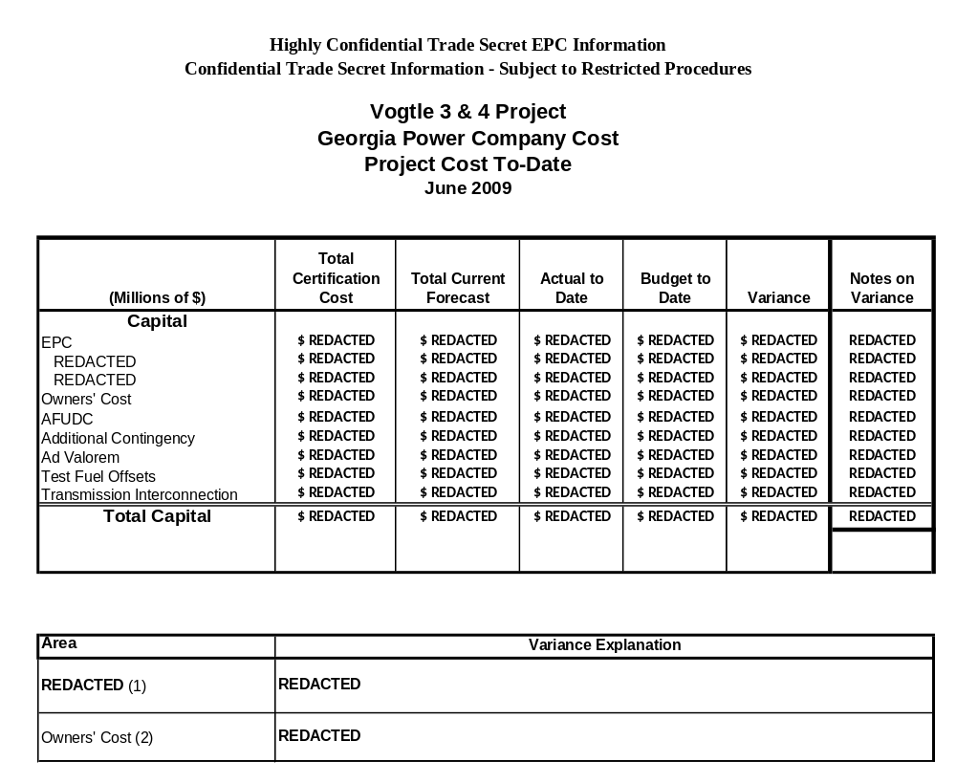

- A description of any cooperative actions between other builders of nuclear units in the southeast to address labor, crafts, engineering and management requirements.

Currently Southern Nuclear cooperates with other builders of nuclear units to address labor, crafts, engineering and management requirements via industry related groups. These groups provide forums for builders of a given technology type to consider issues common to the participants, including possible labor issues. Currently, labor issues are addressed via joint training standards and programs that are being developed between the members of the groups. The groups operate under strict anti-trust rules and do not collaborate in any way to influence the labor markets.

- An explanation of how the indices used in the EPC contract are tracking.

The REDACTED and REDACTED are currently tracking REDACTED estimates, as shown in Tables 3.1 and 3.2. The total approximate dollar variance resulting from the difference between the estimated indices and the actual indices are REDACTED REDACTED REDACTED REDACTED REDACTED REDACTED REDACTED REDACTED REDACTED REDACTED REDACTED REDACTED REDACTED REDACTED REDACTED REDACTED REDACTED REDACTED REDACTED REDACTED REDACTED REDACTED REDACTED REDACTED REDACTED REDACTED REDACTED REDACTED REDACTED REDACTED REDACTED REDACTED REDACTED REDACTED REDACTED REDACTED REDACTED REDACTED REDACTED REDACTED REDACTED REDACTED REDACTED REDACTED REDACTED REDACTED REDACTED.

Table 3.1
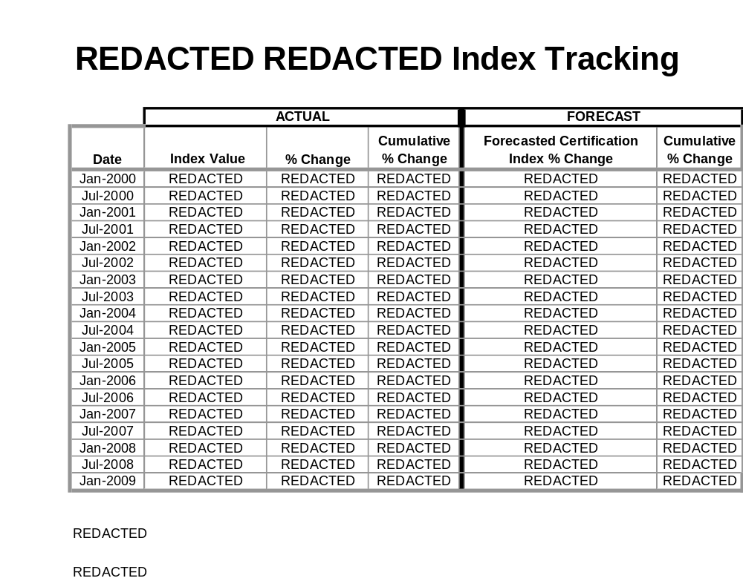

Table 3.2

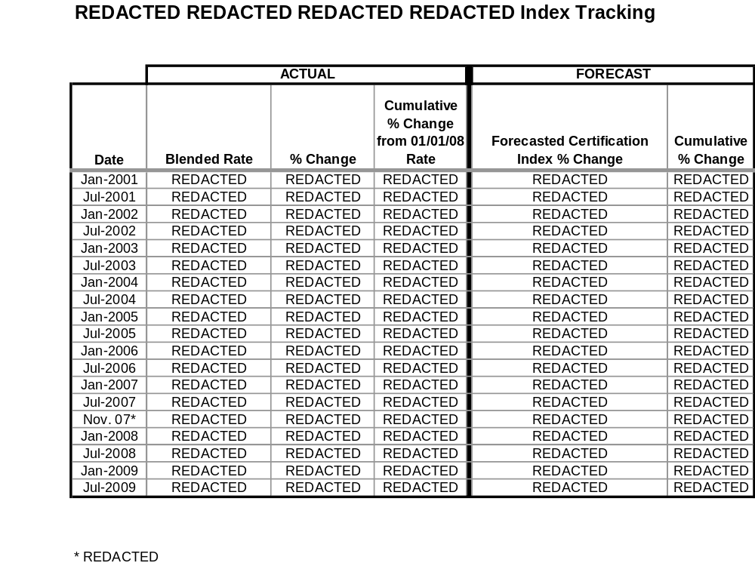

- Any updated estimate of on site spent fuel storage costs, including the costs for dry storage of spent fuel for an extended period of time after shutdown, and any updated calculation of spent fuel storage costs assuming Yucca Mountain is never available.

The Company provided a sensitivity analysis for spent fuel storage costs to the Commission Staff and the Independent Evaluator in October 2008 that estimates the cost of on-site storage through 2087, which is ten (10) years beyond the anticipated shutdown of Unit 4. There is no change at this time to the estimate provided in October 2008.

In November 2008, Southern Nuclear executed a contract with the Department of Energy (“DOE”) that requires the DOE to complete removal of spent fuel from Vogtle Units 3 and 4 within ten (10) years from the date of the shutdown of Unit 4.

- The status of the Company’s loan guarantee application at the Department of Energy and to the extent that application is granted, then the Company shall also report on the impact it has or would have on the final expected in-service cost of the units.

The Company filed part one of its application to the DOE for loan guarantees on September 29, 2008 and filed part two on December 19, 2008. The Company submitted the 90 day updates required by the DOE on March 19, 2009 and on June 17, 2009.

The DOE is authorized to provide loan guarantees of up to $18.5 billion. The Company is requesting up to $REDACTED.

The DOE Credit Review Board has approved the Project as one of the approved projects that will proceed to advanced due diligence. Advanced due diligence will begin in the fall of 2009. As discussed in item 1, since all financing costs will be recovered through rates during the construction period, the ultimate in-service cost of the Units will not be impacted by the availability of the loan guarantees.

No projects have been approved by DOE for loan guarantees at this time.

- Whether the Company is using trust preferred financing and the impact it has or would have on the expected in-service cost of the units.

The Company has not issued trust preferred financing since 2004 and currently has no plans to do so. The Company does not currently view trust preferred financing to be an economic financing choice. This view is based on the high cost of trust preferred financing compared to senior note financing and the low level of equity treatment awarded it by the major credit rating agencies. The Company continues to monitor the security markets and update its financial policies as needed in an effort to minimize overall financing costs for customers.

- The extent to which the Company is using short term debt and the impact it has or would have on the expected in-service cost of the units.

Under a prior stipulation with the Commission, the Company has been directed to first apply its short term debt balances towards financing of under-recovered fuel balances before directing the remaining balances to finance CWIP. Through June 2009, substantially all short term debt has been applied to the under-recovered fuel balances. However, as discussed in item 1, since all financing costs will be recovered through rates during the construction period, the ultimate in-service cost of the Units will not reflect the impact of either short term or long term debt financing.

- An update of the estimated in-service cost and projected date of commercial operation of both units.

An update of the estimated in-service cost of both Units is shown in Table 8.1 below.

The scheduled approved in the certification of the Units provides for a commercial operation date ("COD") for Unit 3 in April, 2016 and a COD for Unit 4 in April, 2017. The current project schedule projects a COD for Unit 3 in REDACTED 2016 and a COD for Unit 4 in REDACTED 2017.
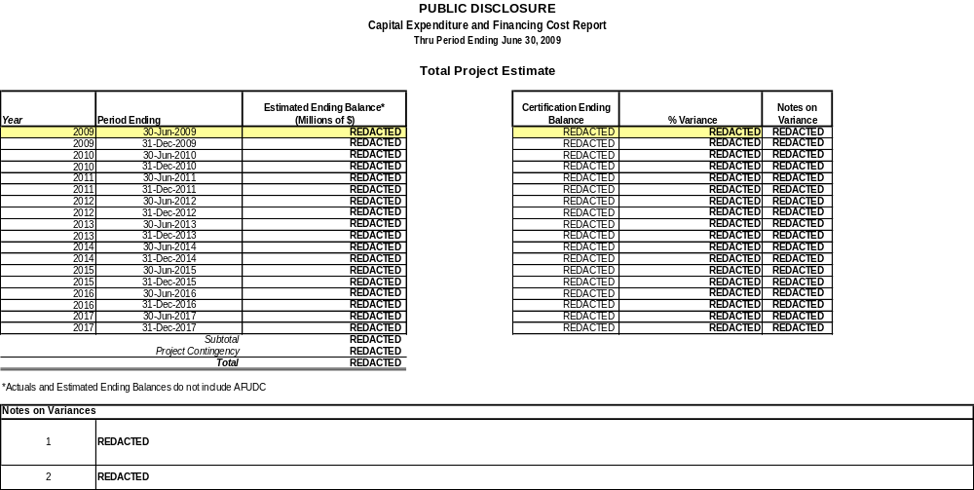
- A description of all major sources of changes (both increases and decreases) to the in-service cost and sources of change in commercial operation dates, if any.

The in-service cost of the Units has been reduced only to reflect CWIP in rate base. No other changes have been made to the in-service cost. Even though some individual line items have changed, the net cost amount of $4.529 billion remains unchanged. Because of the application of the provisions of SB 31, which allows the Company to amortize the AFUDC accrued from certification through December 31, 2010, there is a $REDACTED difference between the original estimate of the CWIP in rate base impact on the in-service cost; however, this difference has been reflected as additional contingency, as previously discussed.

As discussed earlier, the REDACTED and REDACTED are REDACTED REDACTED REDACTED REDACTED REDACTED REDACTED REDACTED REDACTED REDACTED REDACTED REDACTED REDACTED REDACTED REDACTED REDACTED REDACTED REDACTED REDACTED REDACTED REDACTED.
The variance explanations are included in Tables 3.1 and 3.2.

It should be noted that the newly projected in-service amount of $4.529 billion does not include certification fees, construction monitoring fees and independent evaluator fees; however, these costs will be capitalized and put into rate base, and further reported upon in future reports.

There are several issues that the Company is closely monitoring that pose a risk for potential cost increases. These issues to watch include the following:

REDACTED REDACTED REDACTED REDACTED REDACTED REDACTED REDACTED REDACTED REDACTED REDACTED.

REDACTED REDACTED REDACTED REDACTED REDACTED REDACTED REDACTED.

REDACTED REDACTED REDACTED REDACTED REDACTED REDACTED REDACTED REDACTED REDACTED REDACTED REDACTED REDACTED REDACTED REDACTED REDACTED REDACTED REDACTED.

REDACTED REDACTED REDACTED REDACTED REDACTED REDACTED REDACTED REDACTED REDACTED REDACTED REDACTED REDACTED REDACTED REDACTED REDACTED.

While these issues are being actively managed, they are not yet resolved. The Company will keep the Commission informed of the status of these issues and will provide updates in future reports as these issues are resolved.

The projected commercial operation dates are discussed in item 8.

- The status of the Company’s combined construction and operating license (COL) application at the Nuclear Regulatory Commission.

The current schedule for the Company’s COLA is included below. The Company received its Early Site Permit from the NRC on August 26, 2009.

Table 10.1
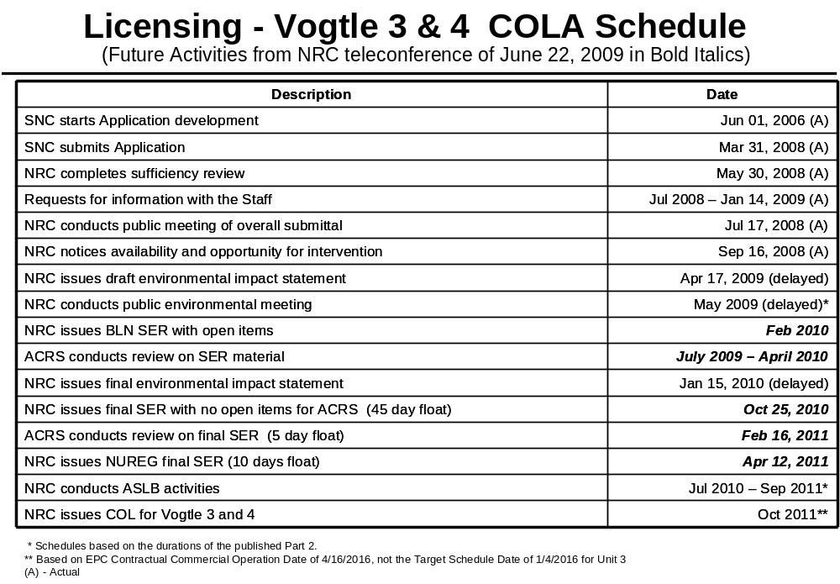

Table 10.2

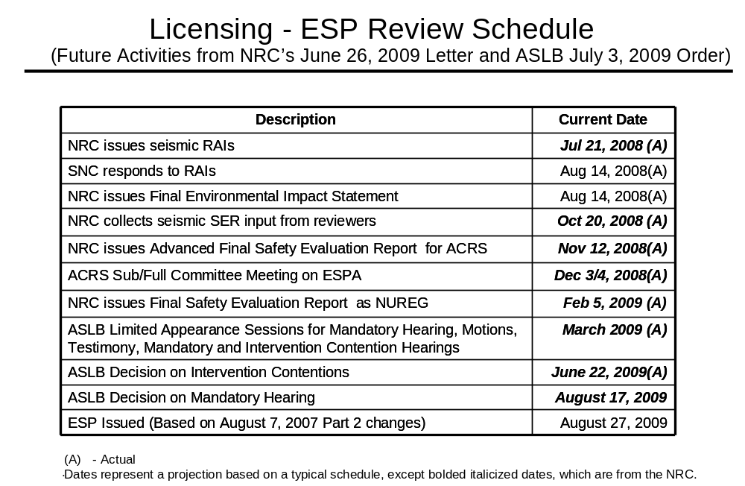
- The status of all other significant permits and licenses required from other governmental agencies.

Table 11.1

Permit | Activity Covered | Permitting Agency | Jurisdiction | Estimated Application Date | Projected Received Date | Required Date | Responsibility | Notes
Early Site Permit (ESP) and Limited Work Authorization (LWA) | ESP -Site approval for nuclear plant construction; LWA - approval for limited safety-related work | NRC | Federal | Actual August 2006 | REDACTED | REDACTED | SNC
Combined Operating License (COL) | Safety related construction for a nuclear power facility | NRC | Federal | Actual March 31, 2008 | REDACTED | REDACTED | SNC
Section 404 Permit | Disturbance of crossing wetland areas or navigable waters | USACE | Federal | REDACTED | REDACTED | REDACTED | SNC | 1, 7,8
Section 10 Permit | Barge slip, new intake/discharge to Savannah River | USACE | Federal | REDACTED | REDACTED | REDACTED | SNC | 1, 7,8
Section 401 Certification | Compliance with water quality standards | GDNR | State | REDACTED | REDACTED | REDACTED | SNC | 7,8
State Waters Buffer Variance | Land disturbing activities within 25’ state waters buffer | GDNR | State | REDACTED | REDACTED | REDACTED | SNC
Certificate of Registration | Transportation of Hazardous Material | USDOT | Federal | Actual May 14, 2009 | Actual May 14, 2009 | REDACTED | SNC | 11
Federal Depredation Permit | Adverse impacts on protected species and/or their nests. For site and rail corridor upgrade. | USFWS | Federal | If needed | TBD | TBD | SNC/GPC
Scientific Collecting Permit | Collection of specimens | USFWS | Federal | If needed | TBD | TBD | SNC/GPC
Salvage Permit | Donation or receipt of protected species (bodies, feathers, etc.) for exhibit or scientific study | USFWS | Federal | If needed | TBD | TBD | SNC/GPC
Objects Affecting Navigable Airspace -  Construction Notice | Notice of erection of structures (>200’ high) potentially impacting air navigation | FAA | Federal | REDACTED | REDACTED | REDACTED | Shaw
Stand-Alone Construction Projects Storm Water Permit | Discharge storm water from site during construction | GDNR | State | Actual October 2008 | Ongoing | Various | SNC
National Historic Preservation Act | Consultation regarding potential to adversely affect historic resources | GDNR | State | REDACTED | REDACTED | REDACTED | SNC | 7, 9
Air Quality Construction Permit | Construction air emission sources | GDNR | State | Actual March 13, 2009 | REDACTED | REDACTED | Shaw | 10
NPDES Wastewater Permit | Regulates limits of pollutants in liquid discharge to surface water | GDNR | State | REDACTED | REDACTED | REDACTED | SNC | 2,7
Air Quality Construction Permit | Construction of plant air emission sources | GDNR | State | Actual May 22, 2009 | REDACTED | REDACTED | SNC
GA Endangered Wildlife Act | Adverse impacts on state designated protected species and/or their habitat. For site and rail corridor | GDNR | State | If needed | TBD | TBD | SNC
NPDES Wastewater Permit | Regulates limits of pollutants in liquid discharge to surface water | GDNR | State | TBD | TBD | REDACTED | SNC | 3
NPDES Wastewater Permit | Regulates limits of pollutants in liquid discharge to surface water | GDNR | State | TBD | TBD | REDACTED | SNC | 3
Infrastructure Projects Construction Storm Water Permit | Discharge storm water from linear construction sites (e.g. Roadways, transmission line and rail corridor) | GDNR | State | TBD | TBD | REDACTED | GPC
General Permit for Industrial Storm Water Discharges | Discharge storm water associated with industrial activity | GDNR | State | TBD | TBD | REDACTED | SNC | 4
Permit to Operate a Public Water System | Operate a public, non-transient, non-community water system | GDNR | State | Actual June 16, 2009 | REDACTED | REDACTED | SNC | 4
Permit to Withdraw Groundwater – Make up Wells 3 and 4 | Consumptive use of 100,000 gallons per day or more of groundwater | GDNR | State | Actual May 26, 2009 | REDACTED | REDACTED | SNC | 4
Permit to Withdraw Groundwater – Dewatering Activities | Dewater for foundation if needed for more than 60 days | GDNR | State | Actual  September 3, 2008 | Actual March 27, 2009 | REDACTED | SNC
Certificate of Abandoned Well(s) – MU-2A | Abandoned wells have been filled, plugged and sealed (notification required 30 days after well is abandoned) | GDNR | State | REDACTED | N/A No response required | REDACTED | SNC
Certificate of Abandoned Well(s) – SW-5 | Abandoned wells have been filled, plugged and sealed (notification required 30 days after well is abandoned) | GDNR | State | Actual February 18, 2009 Notification only | NA – No response required | NA | SNC
Permit to Withdraw Surface Water | Surface water withdrawal | GDNR | State | REDACTED | REDACTED | REDACTED | SNC | 4
Land Disturbing Activity Permit | Permission to conduct land disturbing activities of one acre or larger, or within 25’ of any state waters | GDNR | State | N/A | N/A | N/A |  | 5
Private Industrial Landfill Permit | On-site disposal of solid waste consisting of construction and demolition debris | GDNR | State | REDACTED | Actual Revised D & O Plan Received April 30, 2009 | REDACTED | SNC | 4
Solid Waste Handling Permit | Disposal of industrial solid wastes; transportation of putrescible waste for disposal in a permitted landfill | GDNR | State | N/A | N/A | N/A | SNC | 6
Title V Operating Permit | Operation of air emission sources | GDNR | State | TBD | REDACTED | REDACTED | SNC | 4
Certificate of Public Convenience and Necessity | Present and future public convenience and necessity requiring the operation of such equipment or facility | GA PSC | State | Actual August 1, 2008 | Actual March 17, 2009 Approved by PSC | REDACTED | GPC
General Permit to Transport Radioactive Materials | Transportation of radioactive materials in the State of Georgia | GDNR/  GDPS | State | TBD | REDACTED | REDACTED | SNC | 4
Utility Right-of-Way Permit | Utility right-of-way easement | GDOT | State | TBD | REDACTED | REDACTED | GPC
Tennessee Radioactive Waste License-for-Delivery | Transportation of radioactive materials into the State of Tennessee | TDEC | State | TBD | REDACTED | REDACTED | SNC | 4
Utah Radiation Control Rule | Transportation of radioactive materials into the State of Utah | UDEQ | State | TBD | REDACTED | REDACTED | SNC | 4
Scientific Collecting Permit | State permit for collection of specimens | SCDNR | State | If needed | TBD | TBD | SNC/GPC
Scientific Collecting Permit | State permit for collection of specimens | GDNR | State | If needed | TBD | TBD | SNC/GPC
Land Disturbing Activity Permit | All land disturbing activities within the boundaries of Burke County | Burke County | County | N/A | N/A | N/A | N/A | 5
Building Permit | Construction, alteration, repair, or demolition of any building or structure within the boundaries of Burke County | Burke County | County | N/A | N/A | N/A | N/A | 5
Demolition Notification | Notice of demolition of buildings or structures | GDNR/  Burke County | State/  County | Various – first notification submitted in October 2008 | Various | Various | SNC
Land Disturbing Activity Permit | All land disturbing activities within the boundaries for transmission construction | Various | County | N/A | N/A | N/A | N/A | 5

Notes on Variances
1 | Permit application to be submitted in accordance with USACE regulations; Corps Master permit to cover barge slip, intake and discharge.
2 | If needed for Batch Plant
3 | Modification to existing permit – one for Unit 3 and one for Unit 4
4 | Modification to existing permit; early filing planned pending receipt of intake design from Shaw
5 | Not applicable since GPC is exempt pursuant to O.C.G.A 12-7-17 (10)
6 | Existing Permit – no modification required
7 | Pending final design info from Shaw
8 | All items related to Corps Master permit
9 | MOU for SHPO temporarily delayed pending evaluation of Shaw inquiry on potential for relocation of intake structure
10 | Shaw Air SIP permit for construction issued June 18, 2009 by Georgia EPD; modification of permit will be required due to changes in equipment needs and specifications by Shaw. Permit modification in process.
11 | Electronic renewal process

- The status of procurement, engineering, fabrication, transportation and erection of major equipment.

Consortium Responsibilities. Under the EPC Agreement for the construction of the new Units 3 and 4, the Consortium has the responsibility for all activities involving the procurement, engineering, fabrication, transportation and erection of major equipment. Georgia Power, through its agent Southern Nuclear, is overseeing those activities to confirm that the Consortium is abiding by the terms of the EPC Agreement and that the Project meets the standards of quality demanded by Georgia Power.

As part of the Owner’s oversight function, Georgia Power, through its agent Southern Nuclear has developed a Procurement Project Manager position. The responsibilities of this position include developing and implementing a strategy for the Vendor Technical Surveillance Program as well as managing Supply Chain activities. The position will also ensure that the equipment needed for the Units fully meets the technical and schedule requirements including transportation that are necessary to support schedule commitments and provide for long-term reliability of the new Units.

Status of Procurement. The Consortium’s current procurement activities are proceeding in a manner that is consistent with meeting the Project schedule. The June 2009 EPC Status Report provides detailed information regarding the status of procurement.

Engineering. Engineering activities supporting the completion of the Westinghouse AP1000 standard design continue on schedule. The June 2009 EPC Status Report provides detailed information regarding the status of engineering. REDACTED REDACTED REDACTED REDACTED REDACTED REDACTED REDACTED REDACTED REDACTED REDACTED REDACTED REDACTED REDACTED REDACTED REDACTED REDACTED REDACTED REDACTED REDACTED REDACTED REDACTED REDACTED REDACTED REDACTED REDACTED REDACTED REDACTED REDACTED REDACTED REDACTED.

Fabrication. Module fabrication activities are proceeding on schedule. The June 2009 EPC Status Report provides the detail information regarding the status of fabrication. REDACTED REDACTED REDACTED REDACTED REDACTED REDACTED REDACTED REDACTED REDACTED REDACTED REDACTED REDACTED REDACTED REDACTED REDACTED REDACTED REDACTED REDACTED REDACTED REDACTED REDACTED REDACTED REDACTED REDACTED REDACTED.

Transportation. REDACTED REDACTED REDACTED REDACTED REDACTED REDACTED REDACTED REDACTED REDACTED REDACTED REDACTED REDACTED REDACTED REDACTED REDACTED REDACTED REDACTED REDACTED REDACTED REDACTED REDACTED REDACTED REDACTED REDACTED REDACTED REDACTED REDACTED REDACTED REDACTED REDACTED REDACTED REDACTED REDACTED REDACTED REDACTED REDACTED.

Erection of Major Equipment. The Level 1 Schedule and the June 2009 EPC Status Report provide detailed information regarding the status of erection of major equipment.

- The status of transportation links for heavy forgings and modules.

Please refer to the Transportation discussion in item 12 above.

- An updated comparison of the economics of the certified project to other capacity options.

The relative economic value for the Units can be determined by comparing the costs associated with completing, operating, and maintaining the Units over their useful life with the costs to build, operate, and maintain a gas-fired combined cycle (“CC”) unit, which is the next most viable generation alternative. The economic analysis performed for this Report has relied on the methodologies and assumptions used in the economic evaluations conducted in Docket 27800-U. Based on the evidence presented in that docket, the Commission approved Georgia Power’s application for the certification of the Units as modified by the Stipulation between the Commission Staff and the Company. Given that the Commission certified the Units less than six months ago, many of the key inputs are the same, or, are currently in the process of being updated.

Two key factors have been updated for the economic evaluation included in this Report. These are the projected costs to complete the Units and the Company’s cost of debt. The projected costs in this economic evaluation include the additional costs for spent fuel storage as described in item 4 above. The Company’s cost of debt is projected to be lower than was assumed in the evaluations conducted in Docket No. 27800-U. The other factors that are inputs to the economic analysis are currently being reviewed or updated as a part of the Company’s research and analysis for the 2010 Integrated Resource Plan that will be filed in January 2010. The February 2010 Semi-Annual Construction Monitoring Report will include the results of the economic evaluation using these updated factors.

The economic evaluation for the period ending August 2009 compares the costs to complete, operate, and maintain the Units versus the costs to build, operate, and maintain the alternative gas-fired CC unit or units over the same useful life. “Sunk costs” (non-refundable costs already incurred or projected to have been incurred as of August 31, 2009) are excluded from this forward-looking analysis.

The relative economics for the Units, when compared to the gas-fired alternative, vary depending on the assumptions for future fuel prices and cost associated with potential future carbon legislation. In the cases involving some form of future carbon legislation and mid-fuel forecasts or higher, the Project saves customers from $REDACTED to $REDACTED (see Table 14.1 below). In the less likely case of no future carbon legislation and low fuel prices throughout the expected 60 year life of the Units, natural gas CC generation would save customers about $REDACTED. At the same time, construction of a gas-fired power plant to meet the specific capacity needs in 2016 and 2017 has significant risks, as the continued reliance on natural gas-fired generation increases customers’ exposure to volatile natural gas prices. The fuel price cases represent a wide range of possible future fuel prices. The potential costs for future carbon legislation were developed by the Company. The “$REDACTED CO₂” case and the “$REDACTED CO₂” case assumed the costs to comply with potential carbon legislation will equal $REDACTED and $REDACTED above inflation until REDACTED when carbon costs escalate with general inflation rates. Table 14.1 below shows the difference in lifetime costs of building, operating, and maintaining the gas-fired alternative less the lifetime costs of completing, operating, and maintaining Units 3 and 4, with positive savings figures meaning Units 3 and 4 are cheaper than the gas alternative, and similarly, negative savings figures in Table 14.1 meaning the gas alternative is cheaper than Units 3 and 4.

Table 14.1

Relative Savings of Units 3 and 4 versus CC as of August 31, 2009
“Incremental Cost to Complete”
(Net present value of lifetime costs of CC minus Units 3 and 4)

Fuel \ CO₂ | $0 CO₂ | $REDACTED CO₂ | $REDACTED CO₂
High Fuel | REDACTED | REDACTED | REDACTED
SCS 2009 Fcst | REDACTED | REDACTED | REDACTED
Mid Fuel | REDACTED | REDACTED | REDACTED
Low Fuel | REDACTED | N/A | N/A

This analysis shown in Table 14.1 is an economic assessment from an “incremental cost to complete” perspective, which ignores any potential cancellation fees or other costs that would be incurred if the project were stopped as well as any fully-committed construction costs that would not be avoidable in the event the project is cancelled. If the results from the incremental cost to complete evaluation showed it was no longer cost-effective to pursue completing the Units, a second “cancellation” assessment would have been performed to determine the economic value of canceling the Units. The “cancellation” assessment would provide the most appropriate perspective for deciding whether to cancel the Units as it would include the incremental costs to complete the Units along with the impacts of any cancellation fees or other costs associated with canceling the project.

Table 14.1 shows significant savings and benefits to customers from the incremental cost to complete perspective across a wide range of possible future fuel prices and carbon costs. Therefore, a cancellation assessment is not required at this time.

- The Company will be under a continuing obligation to supplement its response to PIA Staff DR STF-TN-1-2 by ensuring that the financing data reflected in the schedules attached to that DR response reflect the most current and updated information at the time of each semi-annual monitoring report. In addition, the Company will provide the most current information shared with each of the Rating Agencies.

To comply with this requirement, the Company is including Trade Secret Exhibits 4 through 6, which provide the following information in vintage order:

- Presentations provided to the major Rating Agencies at the Company’s annual rating agency meeting held on May 19, 2009 in Atlanta, Georgia. Attached as Exhibit 4a is the printed booklet provided to participants and Exhibit 4b is the visual aid presentation.

- An update of Georgia Power’s financial projections for the period 2009 through 2013 including the projected annual income statement, balance sheet, and cash flow statement, attached as Exhibit 5.

- An update to the schedule of Financing Issuances and Balances for the Project through 2020 under CWIP in rate base methodology, attached as Exhibit 6.

EXHIBIT 1

Level 1 Schedule

REDACTED IN ITS ENTIRETY

EXHIBIT 2

June Monthly Report

See Attached Exhibit
EXHIBIT 3

EPC Status Report

REDACTED IN ITS ENTIRETY

EXHIBIT 4

Presentation to major rating agencies at the Company’s annual rating agency meeting held on May 19, 2009 in Atlanta, Georgia

REDACTED IN ITS ENTIRETY

EXHIBIT 5

Update of Georgia Power financial projections for the period 2009 through 2013 including projected annual income statement, balance sheet, and cash flow statement.

REDACTED IN ITS ENTIRETY
EXHIBIT 6

An update to the schedule of Financing Issuances and Balances for the Project through 2020 under CWIP in Rate base methodology.

REDACTED IN ITS ENTIRETY

The June 2009 Monthly Report attached as Exhibit 2 to this Report includes the corrected data to the Level 1 Critical Path schedule. These corrections were discussed with Staff on August 11, 2009.
The $REDACTED reflects AFUDC attributed to Georgia Power only, not AFUDC among all Co-Owners.
In Direct Testimony submitted by Commission Staff Witness, William Jacobs, the amount of contingency for construction of the Units was raised and Witness Jacobs concluded that the Company had dedicated a relatively small contingency amount. (See Direct Testimony of William R. Jacobs, Jr. Ph.D., In the Matter of Georgia Power Company’s Application for Certification of Units 3 and 4 at Plant Vogtle and Updated Integrated Resource Plan, Docket No. 27800-U, Dec. 19, 2008, p. 22, 26.) The $REDACTED difference between the certified amount and the amount resulting from the application of SB 31 is to be held in contingency in the event such funds are needed.

